**Section:** K19GR **Project Group No.:** 9

**FINAL REPORT**

**Title:** UNIVERSITY MANAGEMENT SYSTEM

A WEBSITE DESIGNING PROJECT

|  |  |  |  |
| --- | --- | --- | --- |
| Sr.no | Registration  No | Name of  Student | Roll No |
| 1 | **11908882** | **Aniket Dixit** | **A25** |
| 2 | **11908893** | **Mayara Karthik** | **A26** |
| 3 | **11908724** | **Ashish singh yadav** | **A27** |

**CSE-326 INTERNET PROGRAMING LABORATORY**



**Submitted to: ISHAN KUMAR, Assistant Professor**

Lovely Professional University, Jalandhar, Punjab

|  |  |
| --- | --- |
| INDEX | |
| 1) | **Introduction** |
| 2) | **Contribution of students** |
| 3) | **Tags used** |
| 4) | **Screenshot of website** |

**INTRODUCTION**

University management system also known as UMS is a college management  ERP software which helps to streamline the administrative and academic activities of a college campus. The software helps to computerize the daily chores of a college campus. In the present era, many colleges facing trouble in performing the administrative activities manually. It is often difficult to manage hundreds of paper-based records daily. This is exactly where a **University management system** comes to rescue you. To serve you better, it has become mandatory to move towards new technologies and innovations. A campus management ERP system is a total solution to streamline all the administrative activities of a college. Not only it helps in managing the administrative activities, but it can handle academic and non-academic activities as well.

A college management system is obviously built for college campuses. The software can handle colleges of every size, coaching institutes or even schools. It might seem like it is only helpful for college administration and management. But the features of a **University management system** is not limited to administrative activities. Teachers, students, parents are all the stakeholders that benefit from this fantastic piece of  educational technology.

Now coming to the facilities which are provided to everyone by UMS. First and the best thing is that every faculty , student and their parents have their separate account in UMS. This makes their work easy in many ways. This is helpful to everyone as they can access different facilities easily and can keep a track of what is going on inside the college campus.

The key features of the University Management System are:

1. Students can access and can see their attendance with respect to their courses.
2. Everyday’s time table is uploaded and is displayed on the top of the website. It helps student to remember their class easily.
3. UMS has a section where students can see their upcoming examination with their dates.
4. Students are also given with the announcement section. Here they can see all the announcements that are uploaded everyday by the university.
5. Students can also see that which subject teacher is on leave on a particular day so that they can set their schedule accordingly.
6. Lastly, there is a logout option which redirects you to the login page.
7. If students, by chance misplace or forget their UMS password, then it can be reset using the forget password option in the login form section. Here a reset link will be sent to your entered email ID.

College management software effectively transforms academic delivery, increases operational efficiency and focuses on student success. It carries a number of benefits for student, faculty, and institution. As education landscape going through a constant change, it has become mandatory for educational institutions to implement advanced college management system to overcome current and upcoming challenges.

Therefore, UMS is designed in such a way that it can help students to get access to things easily so they don’t get their time wasted.

**WORK DONE BY STUDENTS**

Name: **ANIKET DIXIT (11908882)**

This project is mainly a college management system which is designed for welfare of all the students, teachers and parents of Lovely Professional University.

**Contribution done:**

**Master Page:** The main page which we get after the login page is called master page. Here we can get different options like details of the student view attendance , today’s timetable, exams available, change password and logout. The options are available in button forms.

**Change Password:** The page for changing the password is done entirely through bootstrap. Bootstrap is an online platform where different links, themes , and online graphics are present which can help us to improve our webpage. Provided that you need to insert the links of bootstrap and other files correctly.

Name: **MAYARA KARTHIK (11908893)**

This project is mainly a college management system which is designed for welfare of all the students, teachers and parents of Lovely Professional University.

**Contribution done:**

**Login page:** The main page where we have to fill out registration number and password is the login page. Here you can enter the main UMS page only after you fill the details in the login page.

**Linking:** The linking of all the web pages to each other so that the website works smoothly is very important. This follows that whenever we click a certain option, a new page or action will occur.

Name: **ASHISH SINGH YADAV (11908724)**

This project is mainly a college management system which is designed for welfare of all the students, teachers and parents of Lovely Professional University.

**Contribution done:**

**Time table:** In this page, students can go and view their weekly time table. Schedule of whole of working days of week is present in this section.

**Examination:** Here , in this section, students can view their upcoming exams and their dates so that they can prepare and get ready for it.

**TAGS USED**

**• <div> :** This tag is used to style or create a box or padding

**• <img> :** This tag is used to import images from our system

**• <hr> :** This tag is used to insert a line.

**• <b> :** It is used to make a sentence bold

**• <center> :** It is used to bring the object in center.

**• &nbsp :** It is used to insert spaces

**• <iframe> :** Used to insert an iframe

**• <form> :** Used in creation of forms

**• <input> :** Used to specify id , class and input types of form

**• <span> :** Used for grouping and applying styles to all the inline elements.

**• <select> :** It is used to create a drop down list of options which appears when user click on form elements.

**• <a href> :** It is used to provide a reference and to redirect to some destination

**• <button> :** Used to insert a button in our webpage

**• <ol> :** It is used to enter an ordered list in our webpage

**• <ul> :** It is used to enter unordered list in our webpage

**• <table> :** It is used to insert a table with rows and columns in our webpage.

**• <td> :** It is used to insert a table element

**• <th> :** It is used to insert a table heading

**• class**

**• id**

**• <link> :** Used to give reference of style-sheets

**• <section> : It defines** the section of documents such as chapters, headers or footers

**• <label> :** It provides a usability improvement for mouse users.

**SCREENSHOTS OF PROJECT**

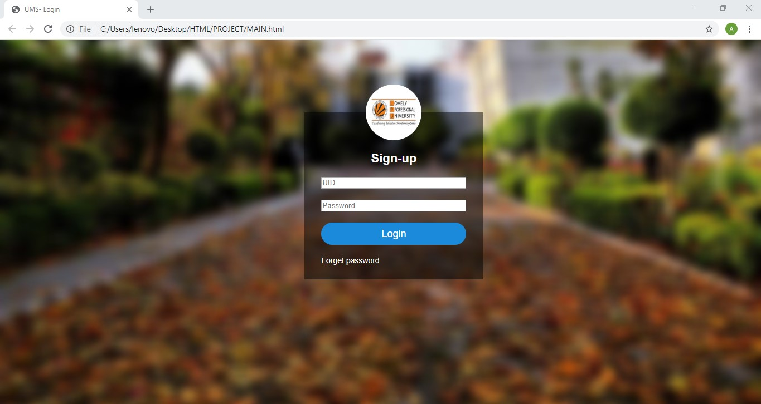

**The LOGIN page**

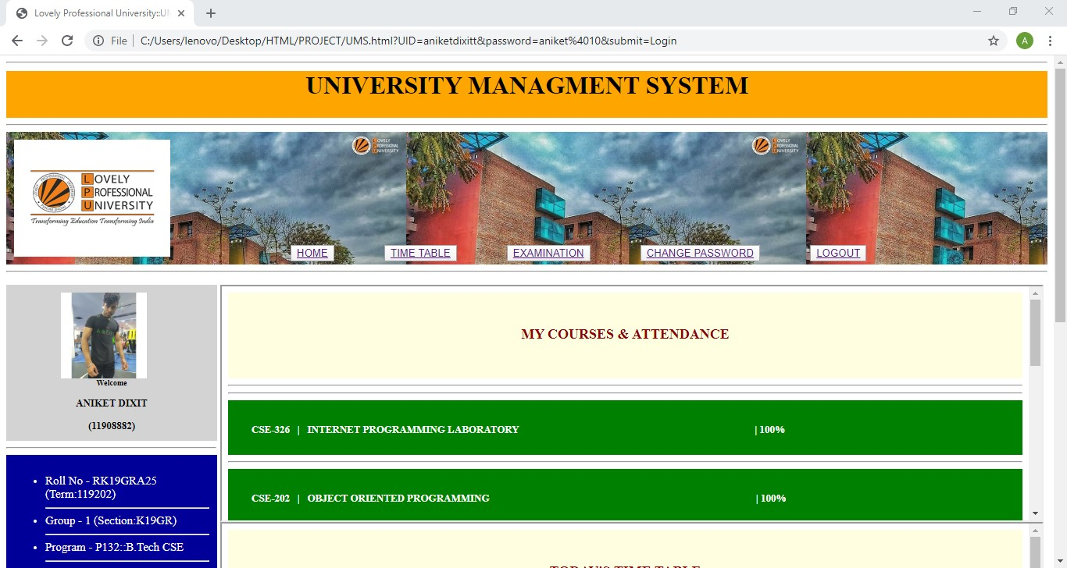

**Main UMS page**

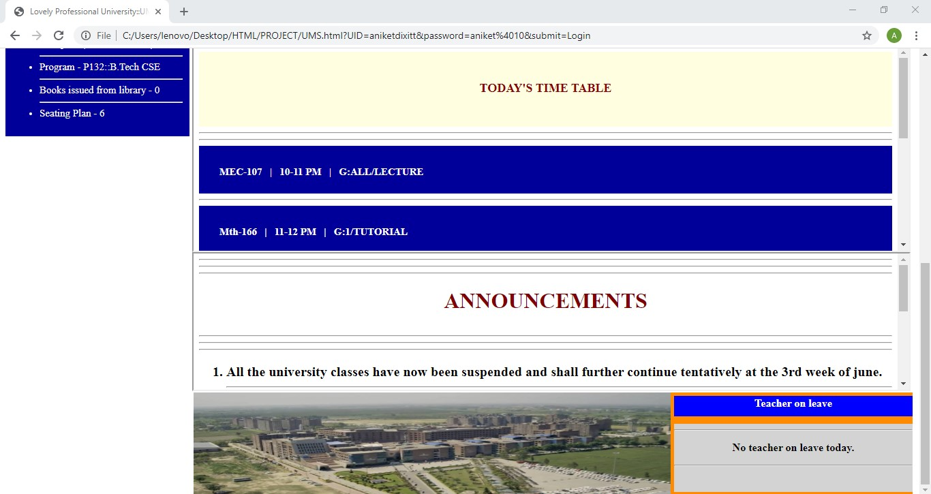

**Scrolled down view of MAIN UMS page**

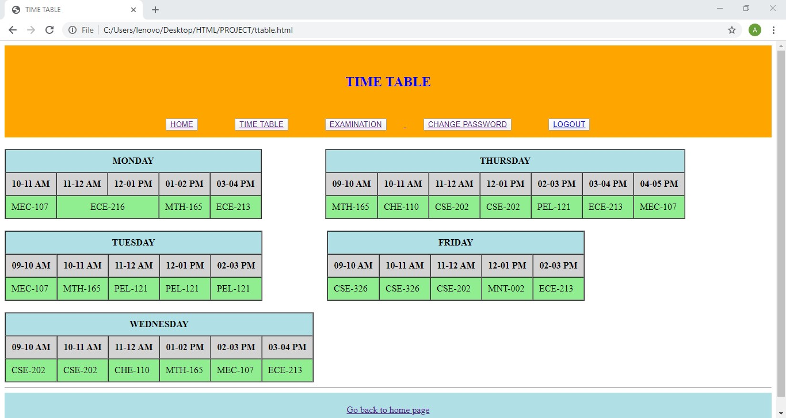

**TIME TABLE view page**

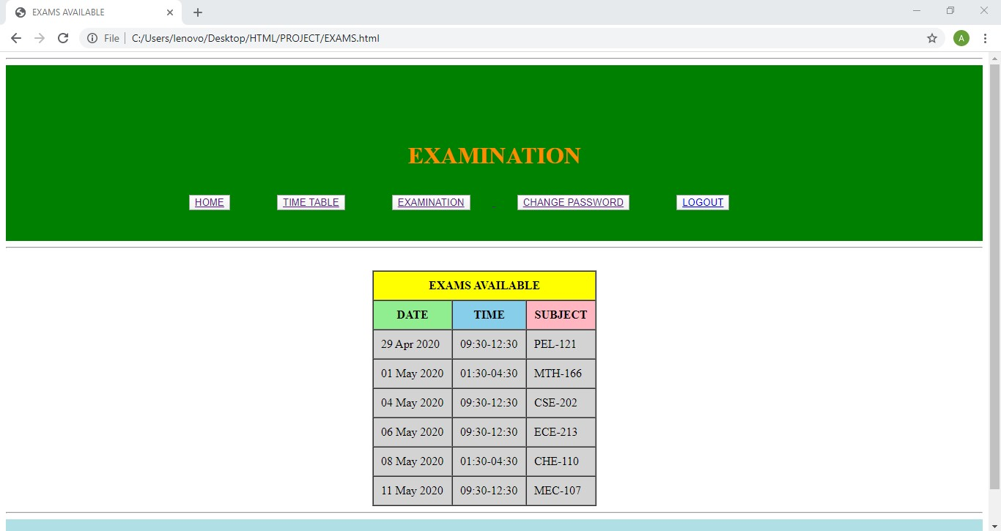

**EXAMS AVAILABLE page**

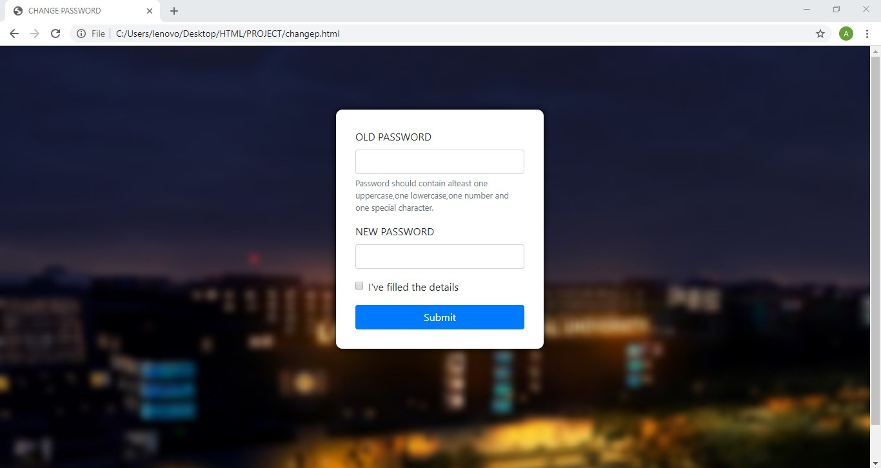

**Page for changing the password. It is done through bootstrap.**

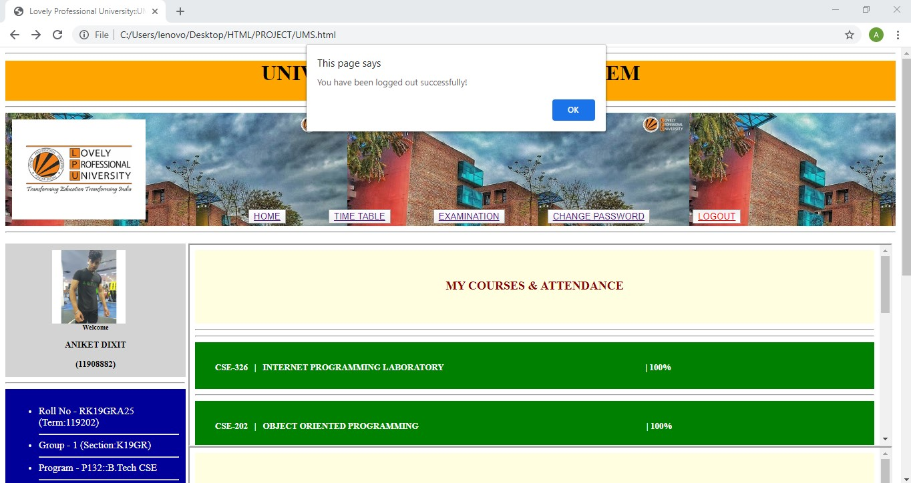

**Finally when you want to log-out, you click the logout button and then this message will be displayed and you will be then redirected to the login page directly.**

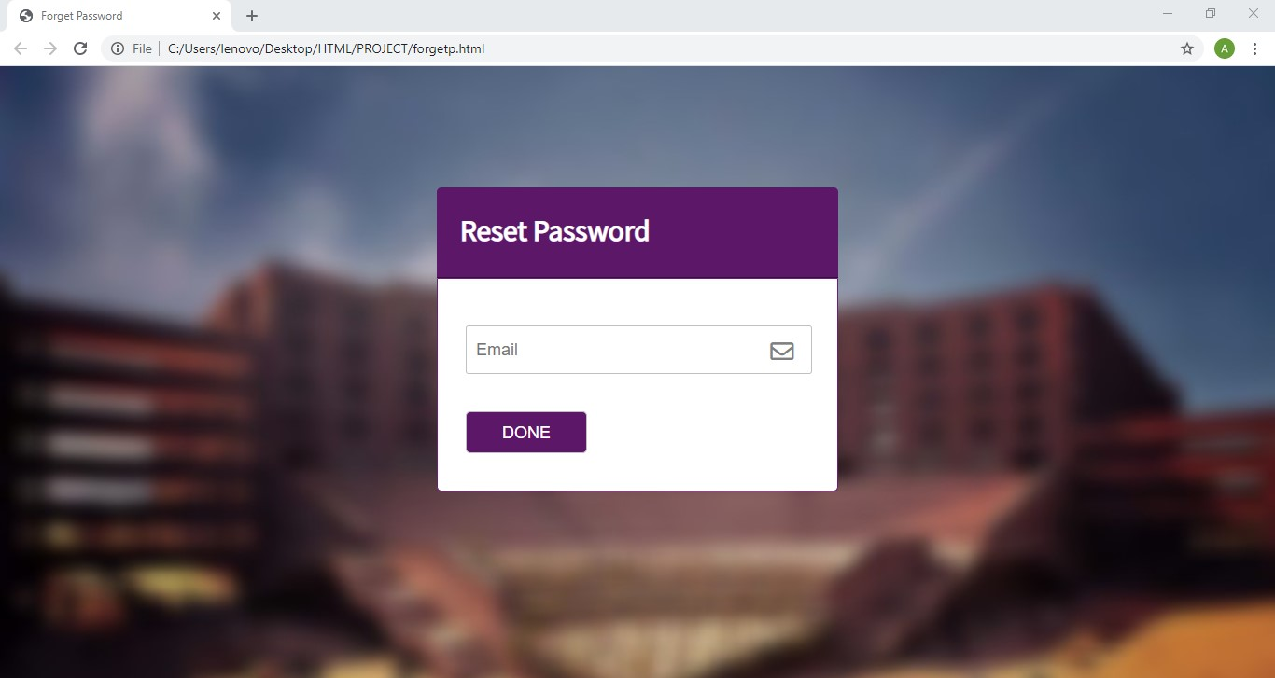

**The forgot password section. Here you can reset your password.**

**THANK YOU!**